NAME: M.Karthik reddy

REG. NO.: 192211477

Experiment no: 12

AIM

To design the two different network with Static Routing techniques using Packet Tracer

REQUIREMENTS:

1. End device - They are the devices through which we can pass message from one device to another and they are interconnected.

2. Switch/Hub - Interface Between two devices.

3. Cable - Used to connect two devices.

4. routers

Procedure:

STEP 1: Click on end devices, select generic Pc’s drag and drop it on the

window. Click on SWITCH drag and drop it on the window. and also connect two routers to the connection with the switch and then to the pc''s

STEP 2: Select the straight through cable and connect all end device to switch. Assign the IP address for all end devices. (Double click the end device Select →

desktop → IP configuration static)

STEP 3: Now set the IP address to Host A (192.168.1.1) in static mode. Similarly set IP address for Host B (192.168.1.2) and Host C (192.168.1.3)

STEP 5: To view the IP address, give ipconfig command in command prompt. Using ping command, we can establish communication between two host devices.

STEP 6: Now display the packet transmission in simulation mode.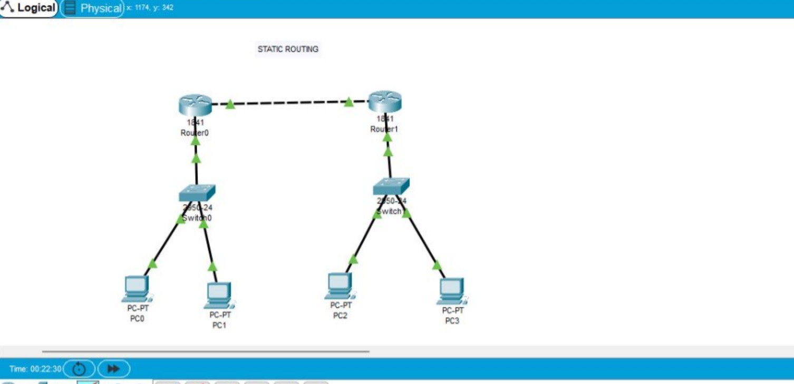

RESULT

To configure the design of two different network with Static Routing techniques using Packet Tracer is successful